**Assignment - AWS**

**Hosting Application on AWS through remote connection using ubuntu remote server.**

**_____________________________________________________________________**

Steps :

1. Sign in to AWS account.

2. Select Data center. (mostly select Mumbai Data center)

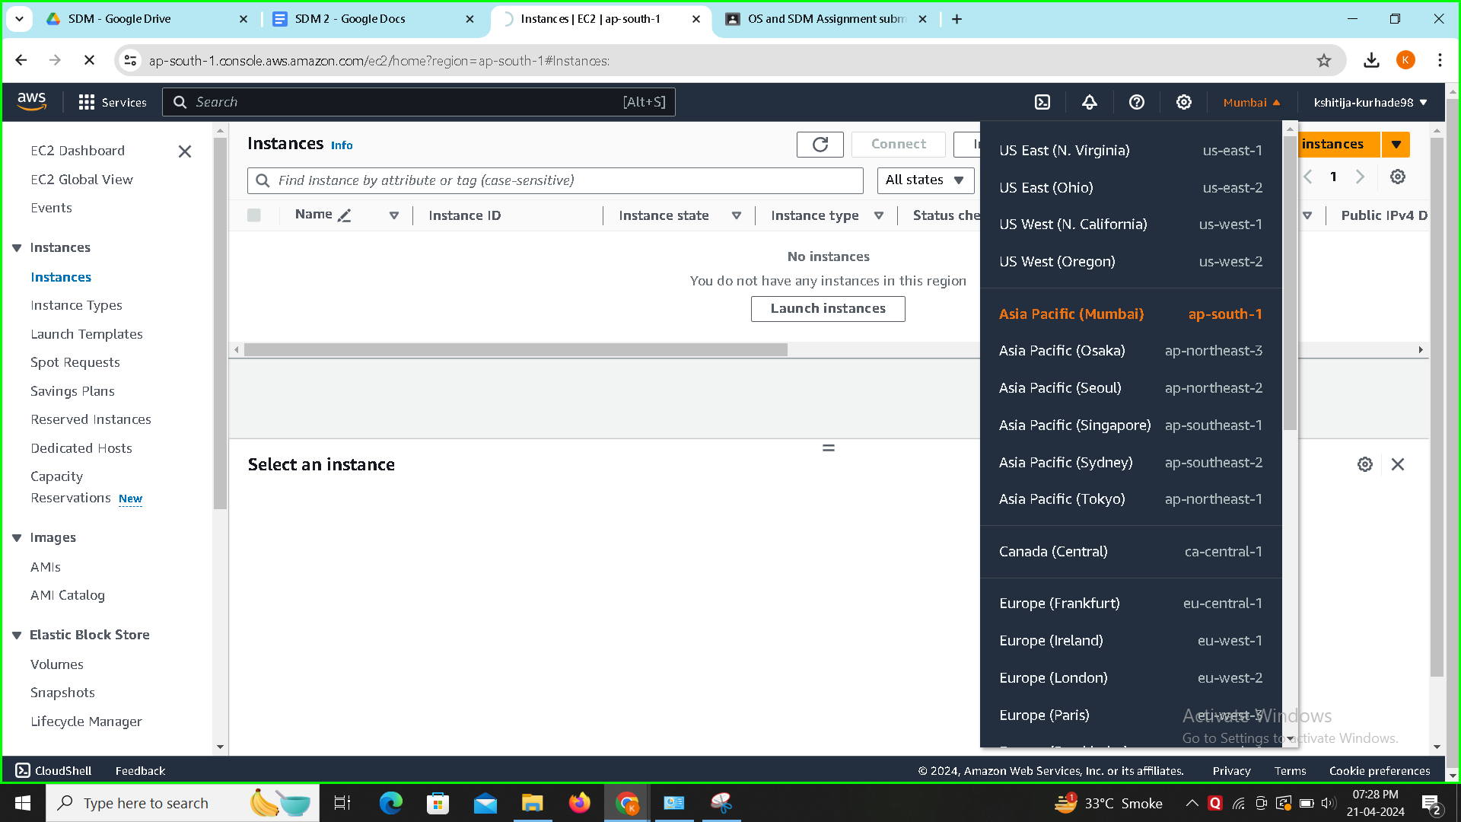

3. Go to Services → Compute → EC2.

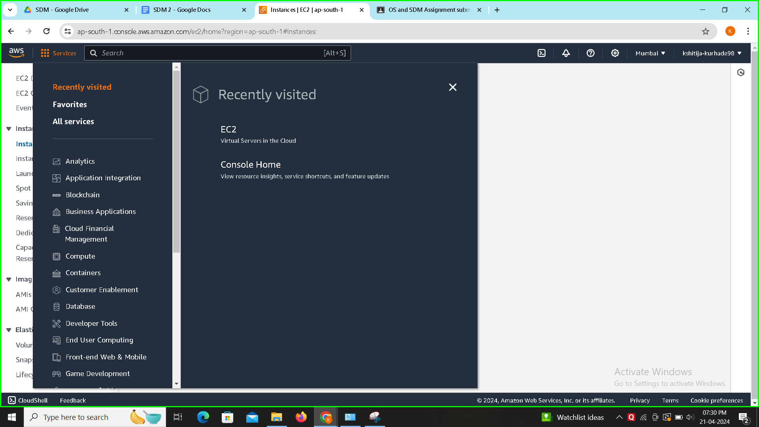

4. Click on Launch Instance.

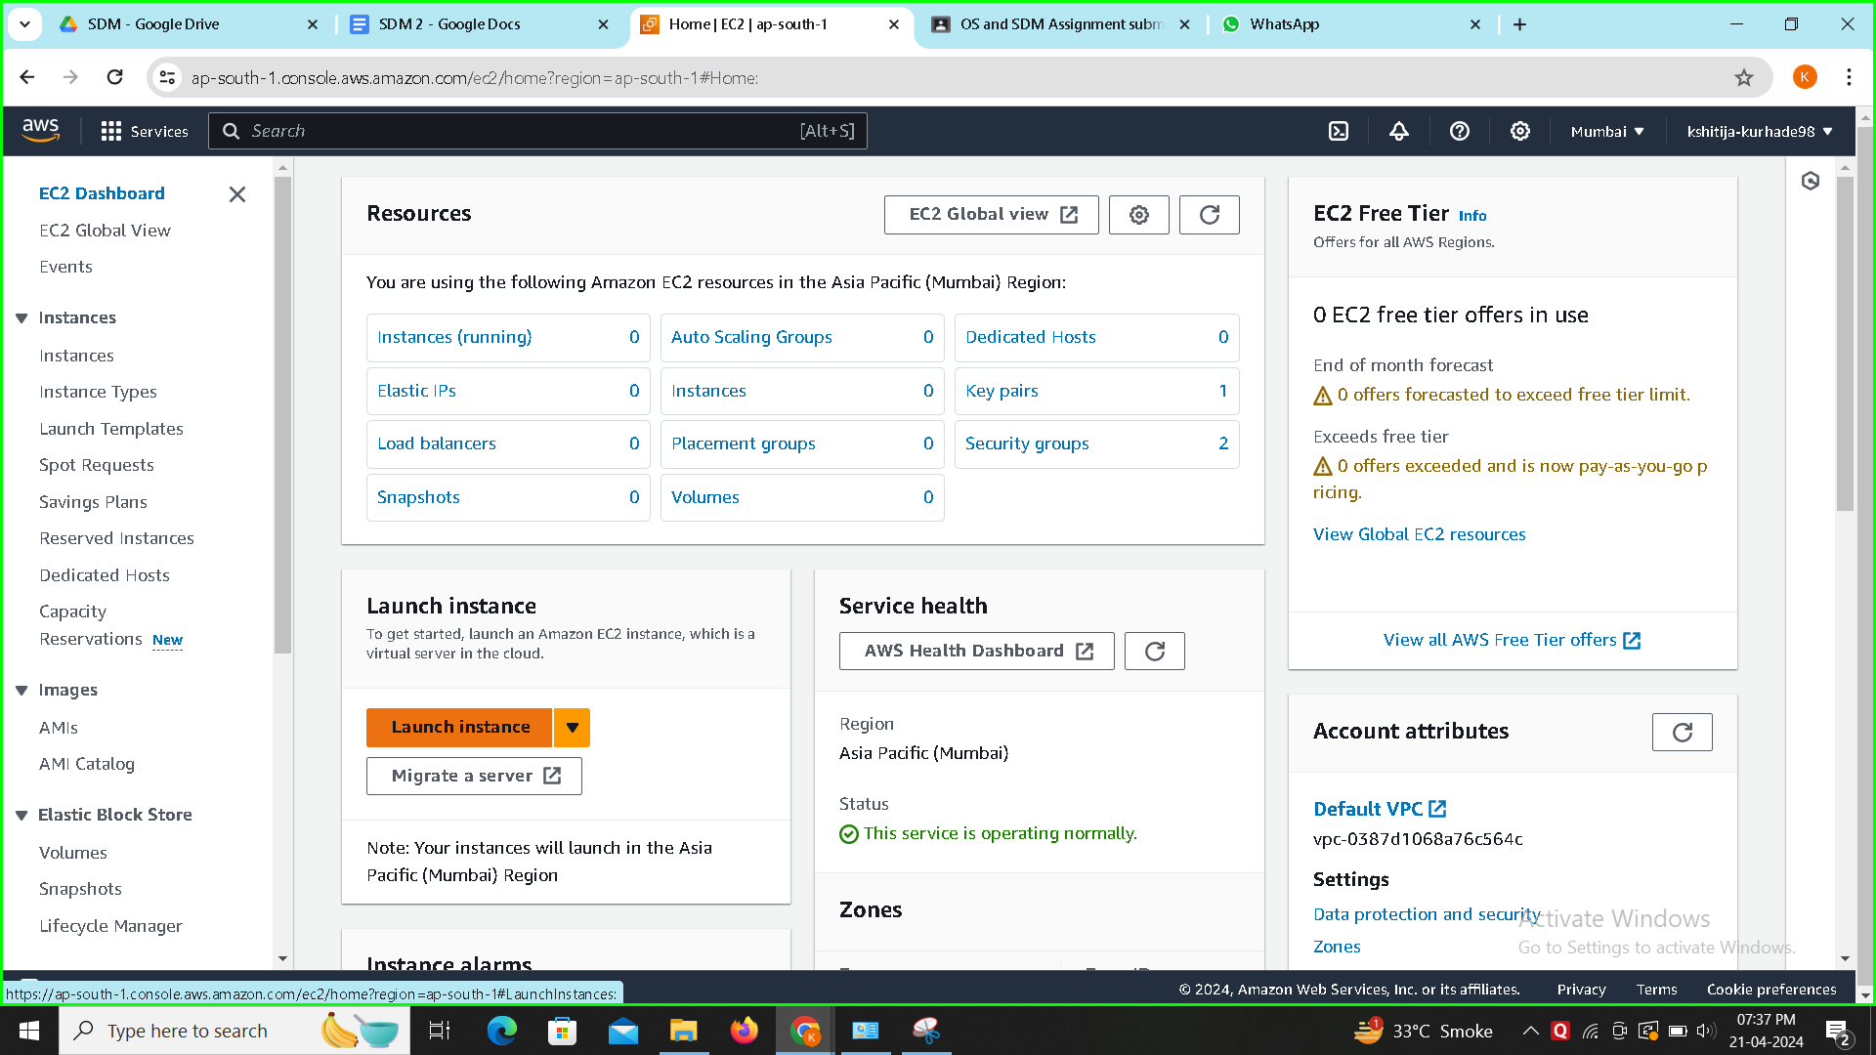

5. Give Name to the Sever.

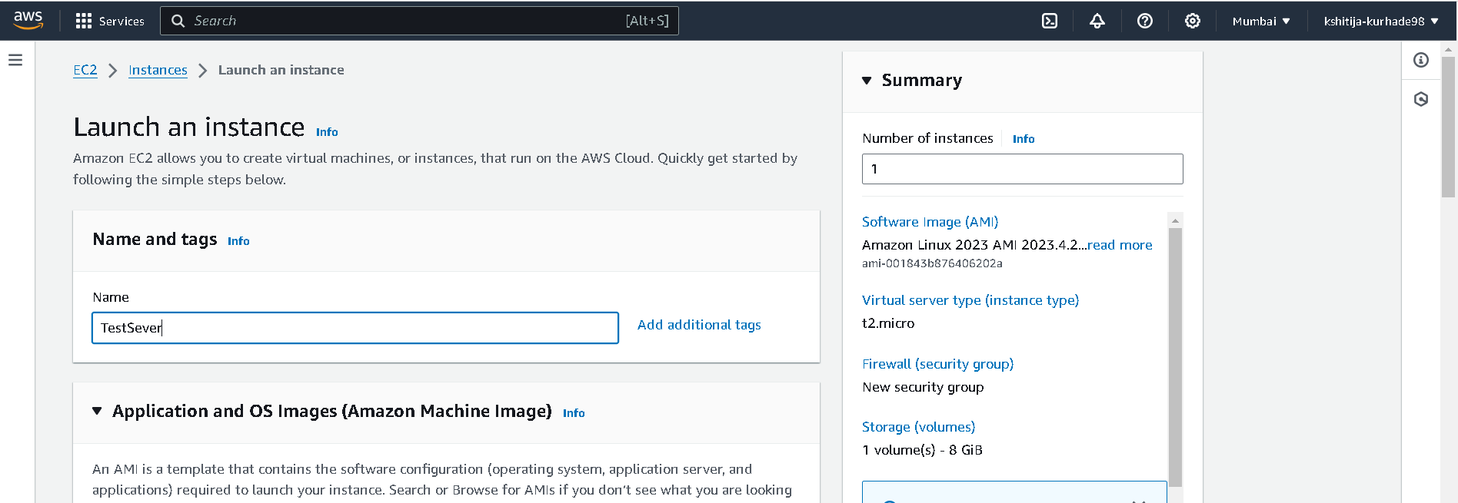

6. Select OS (ubuntu), AMI (select Free tier)

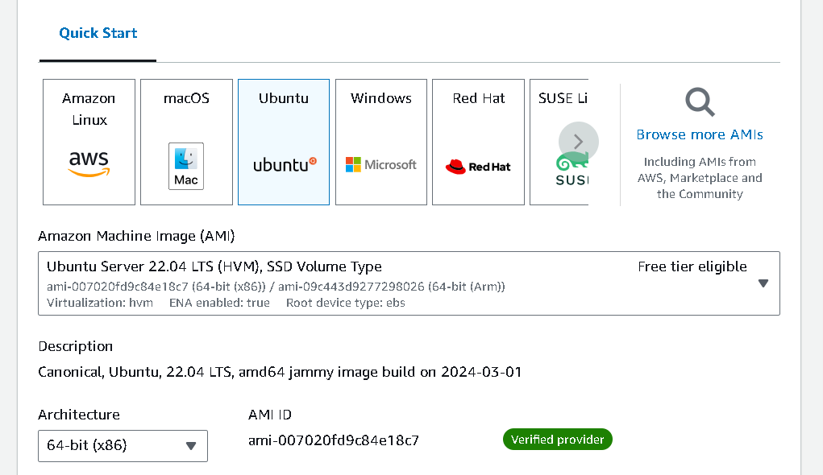

7. Create New Key - Pair.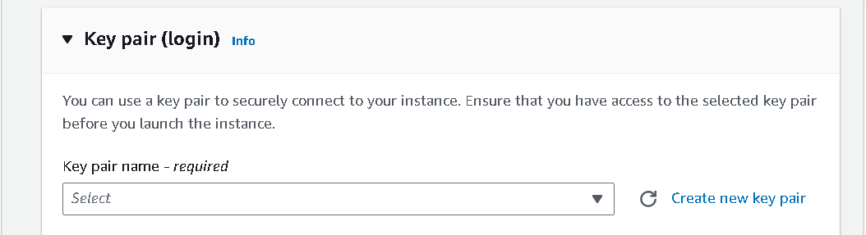

8.Give Name of key → create key.

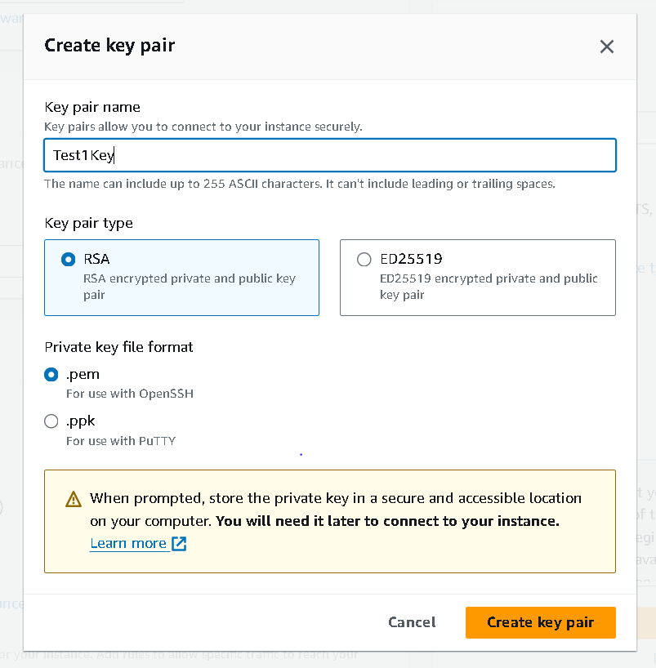

File containing key will get downloaded.

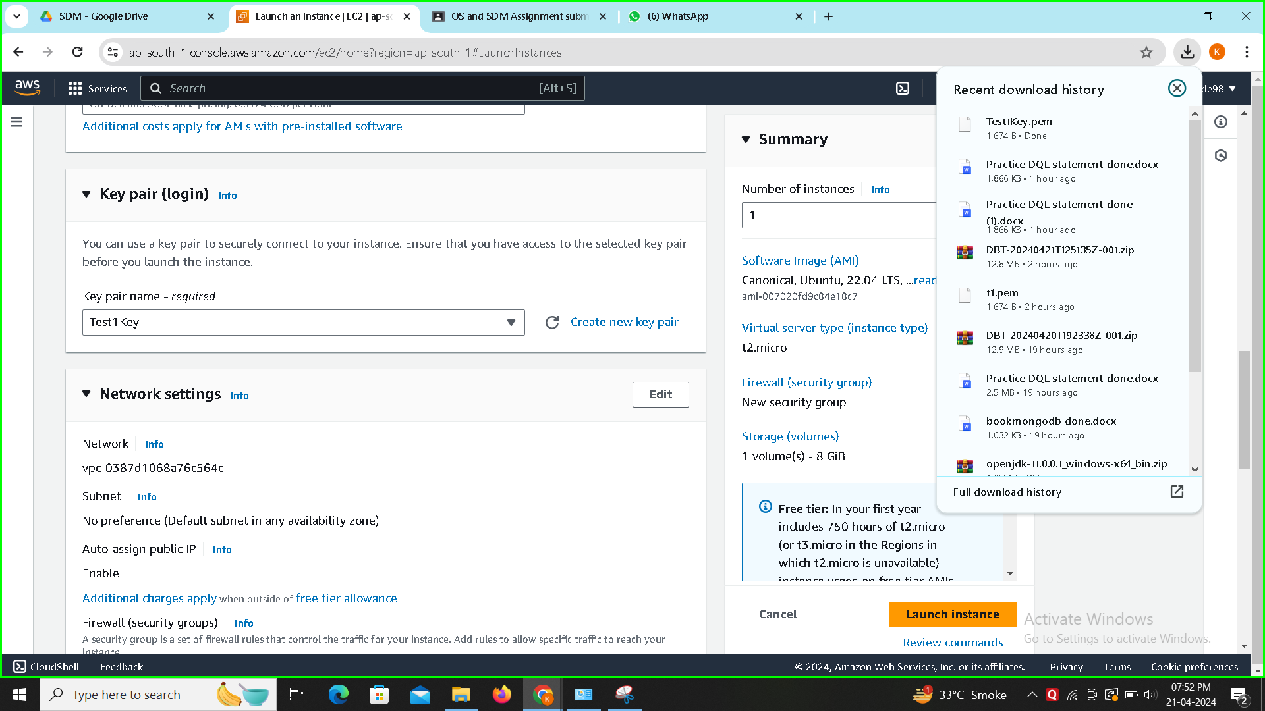

9. Click on Launch Instance.

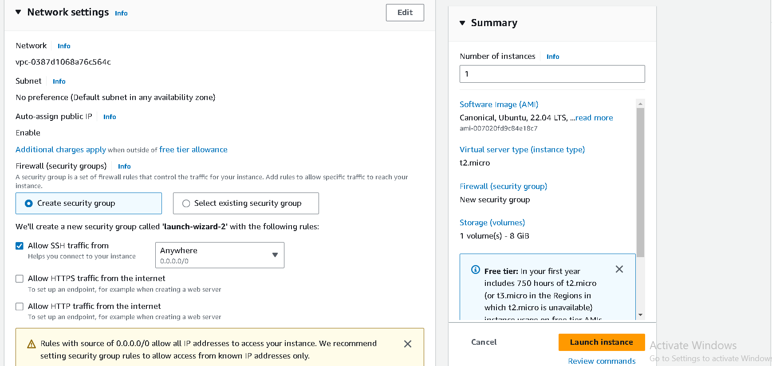

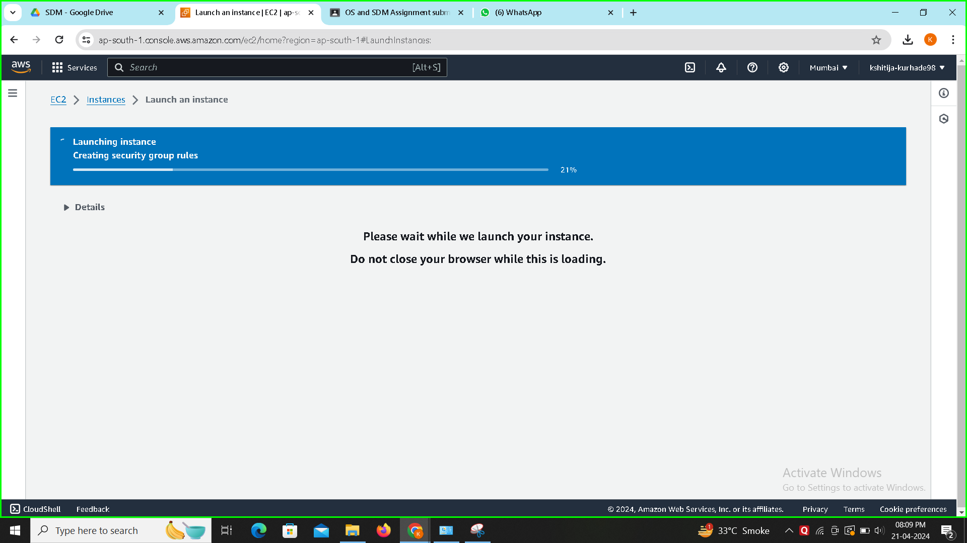

10. To see instance, click on instances.

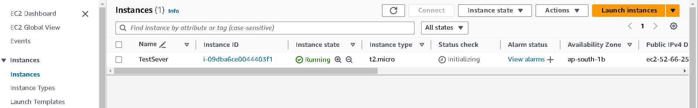

11. Select instance → click on connect.

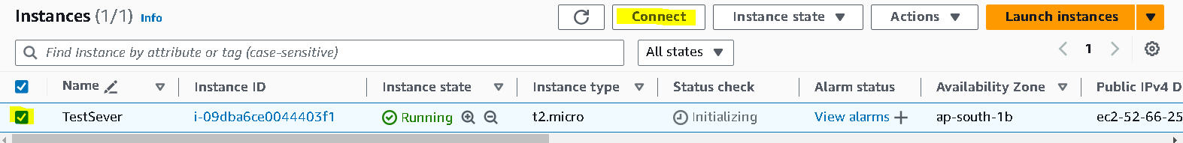

12. Connect to instance.

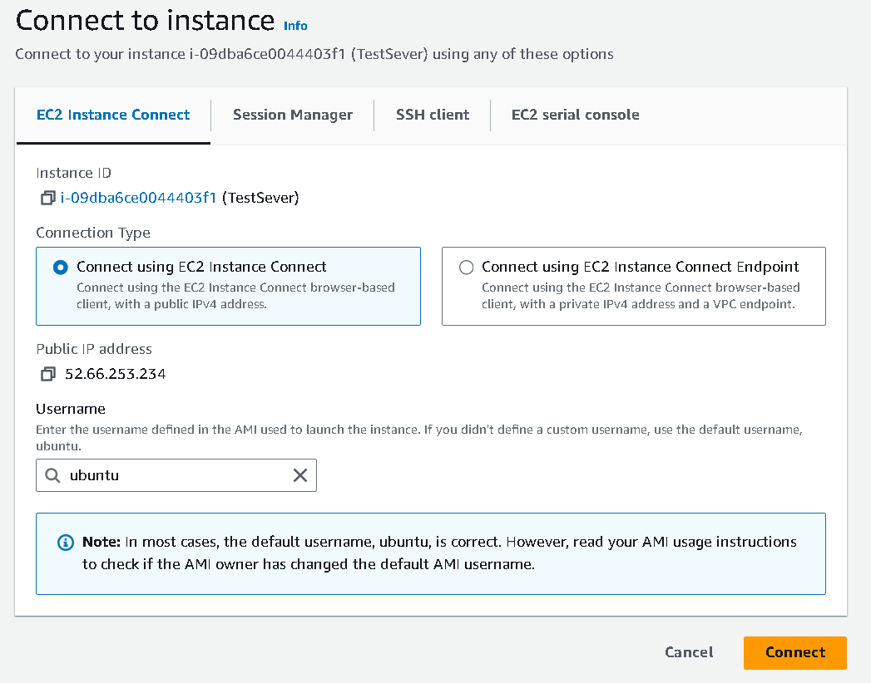

13.

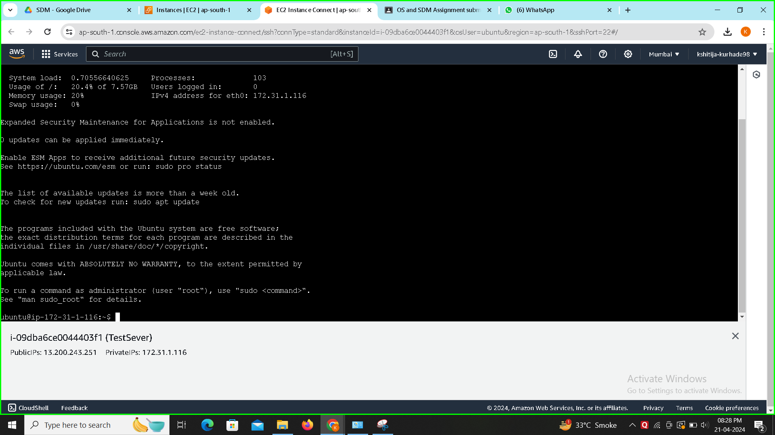

14.

git -v

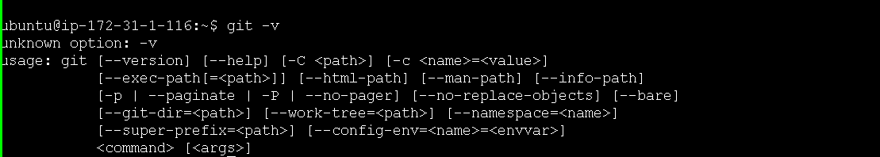

15.

git clone https://github.com/RaviTambade/tflstore.git

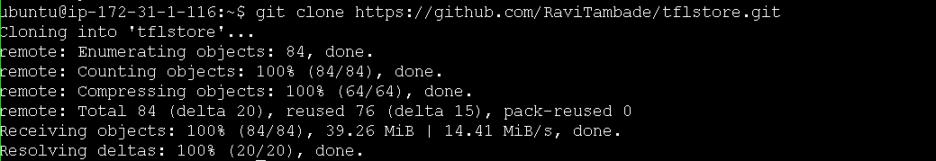

16.

Cd tflstore

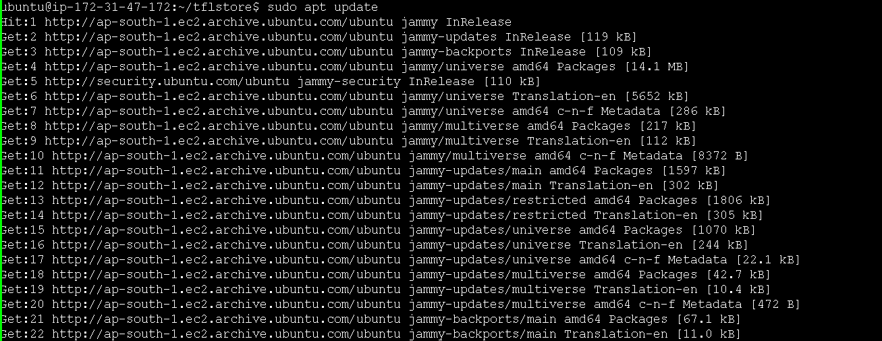

17.

Sudo apt update

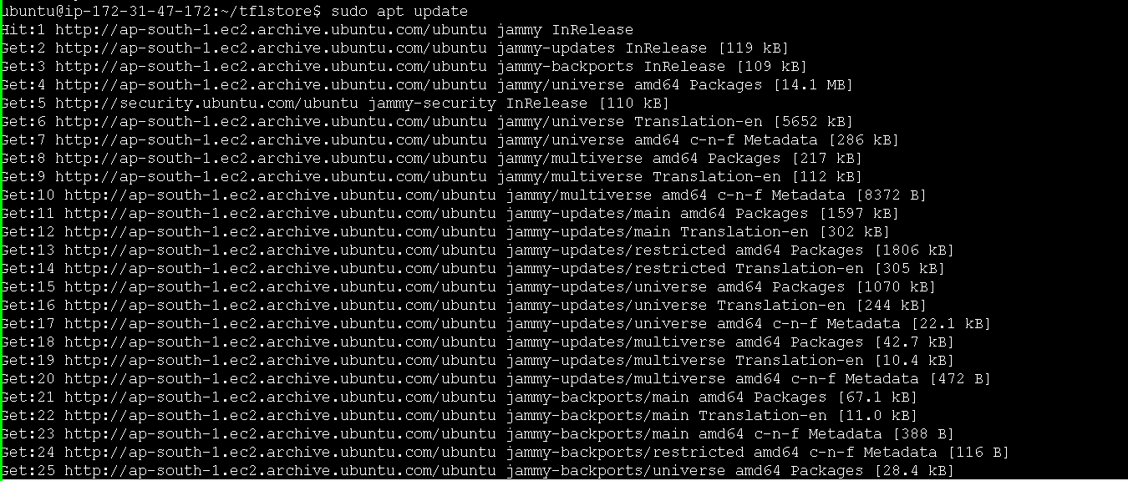

17.

Sudo apt install nodejs

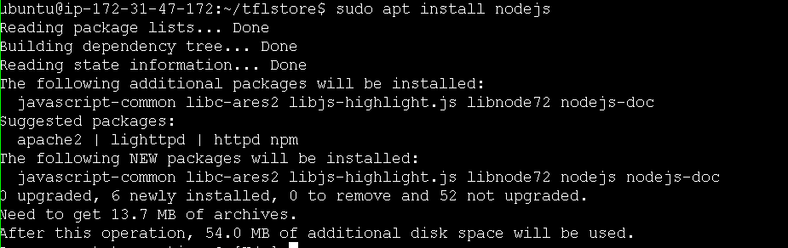

18.

Sudo apt install npm or sudo npm i

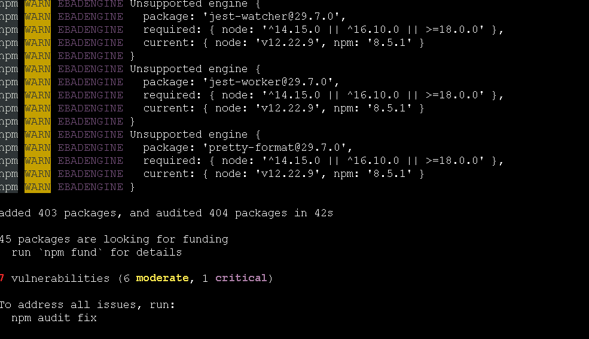

20

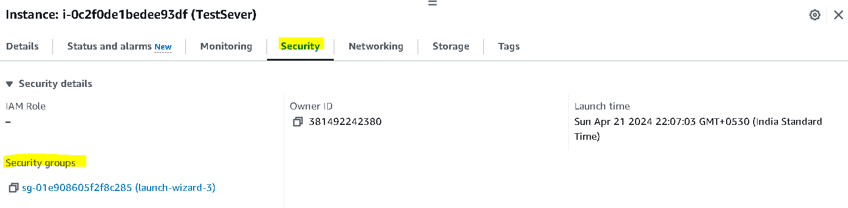

21

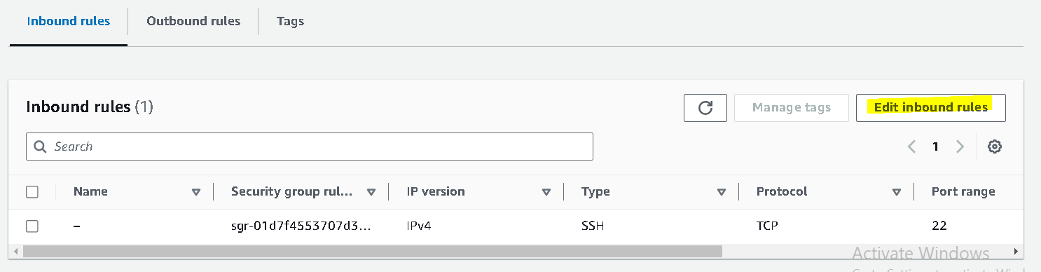

22

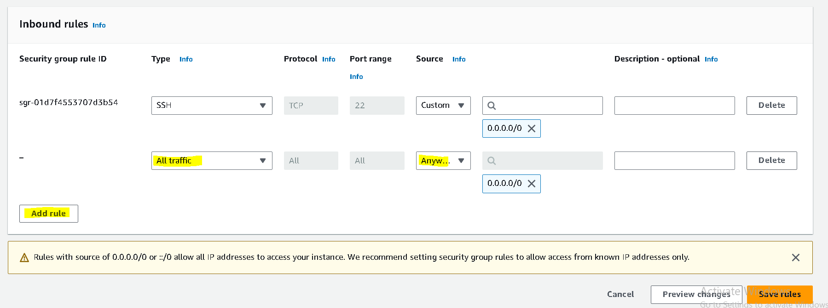

23

Node sever.js



24

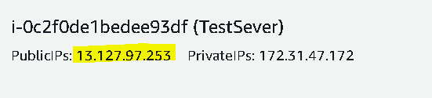

25.

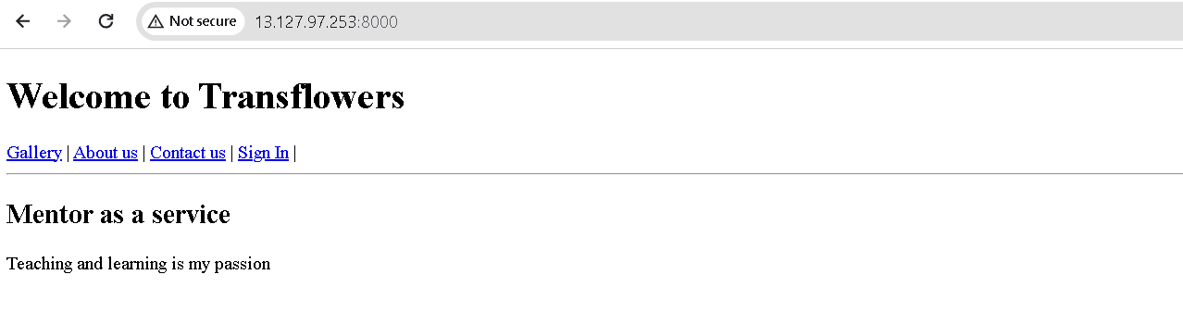

27.

Exit



**Hosting Application on AWS through remote connection using Putty**

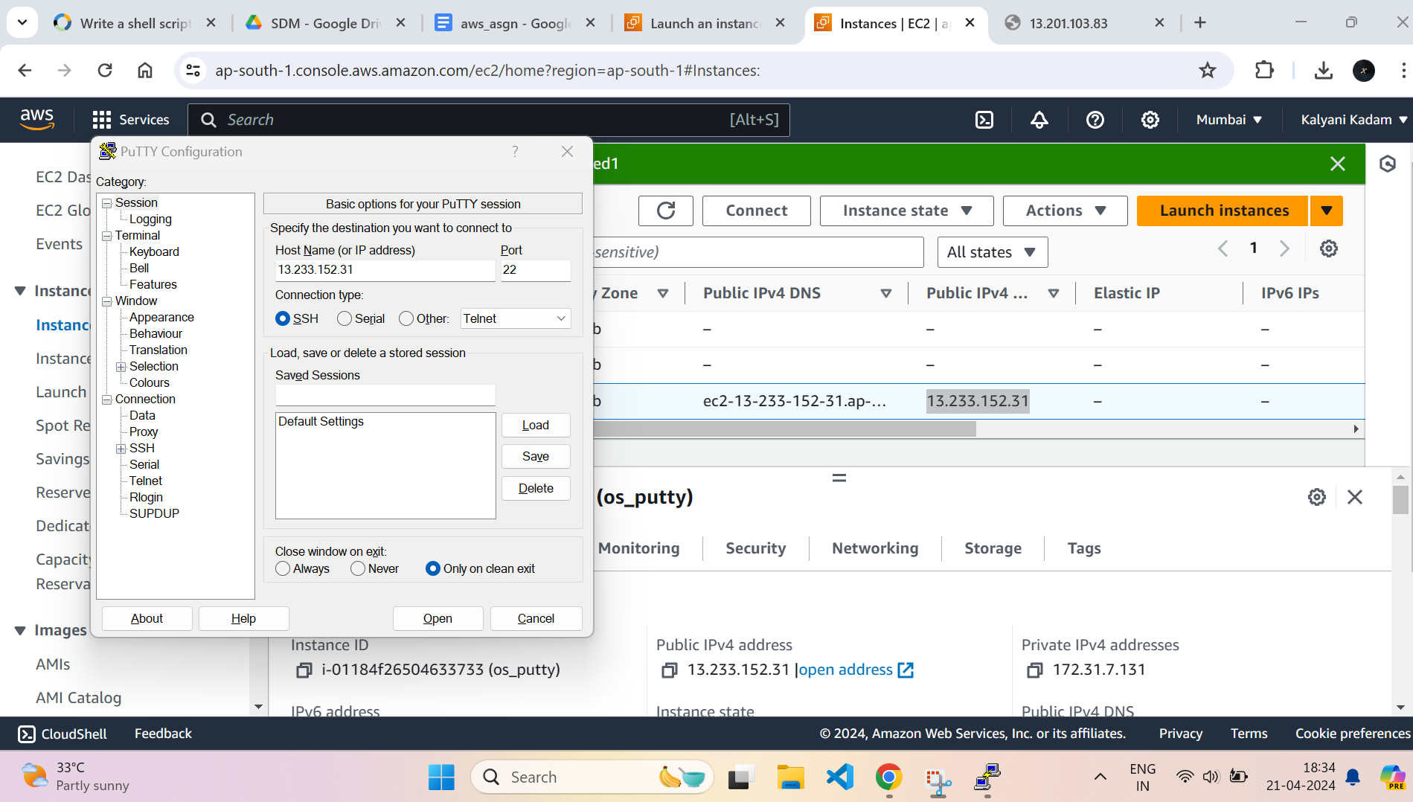

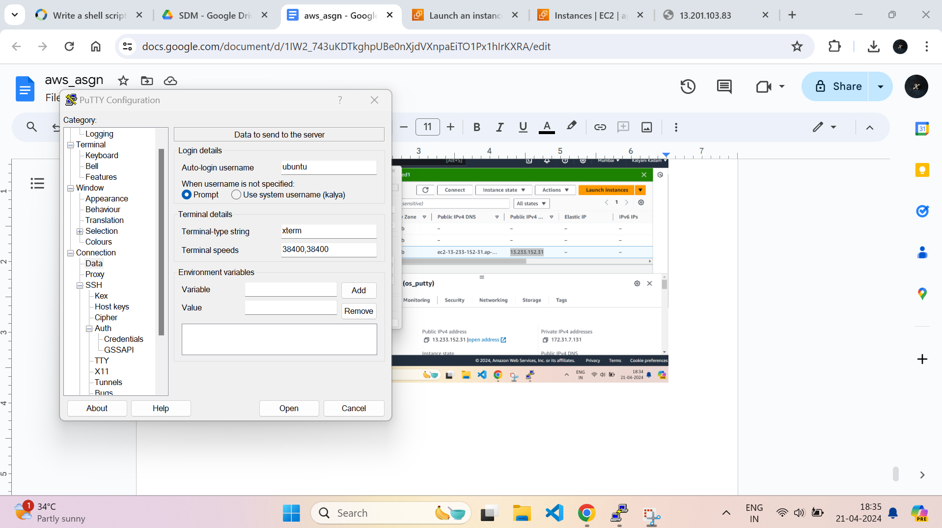

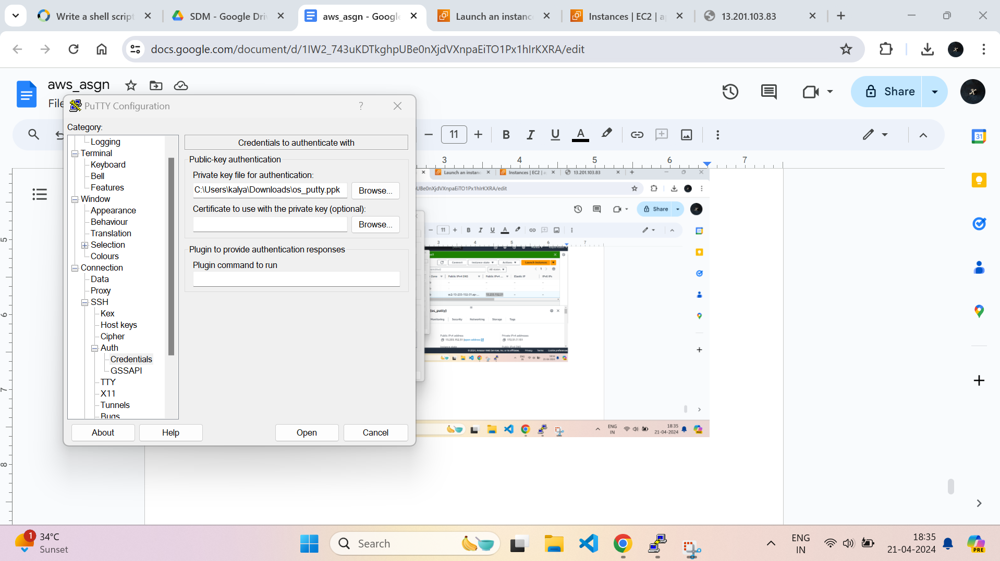

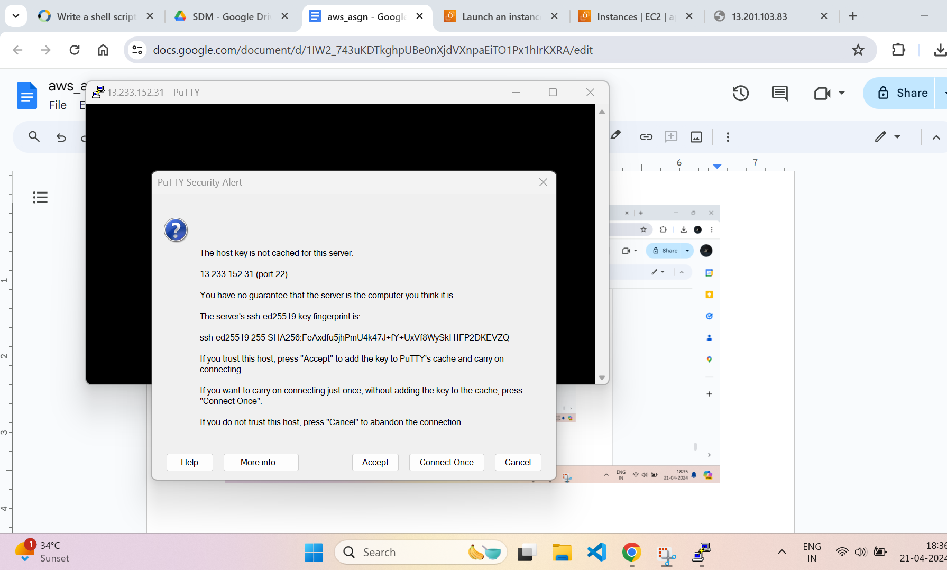

On Putty :

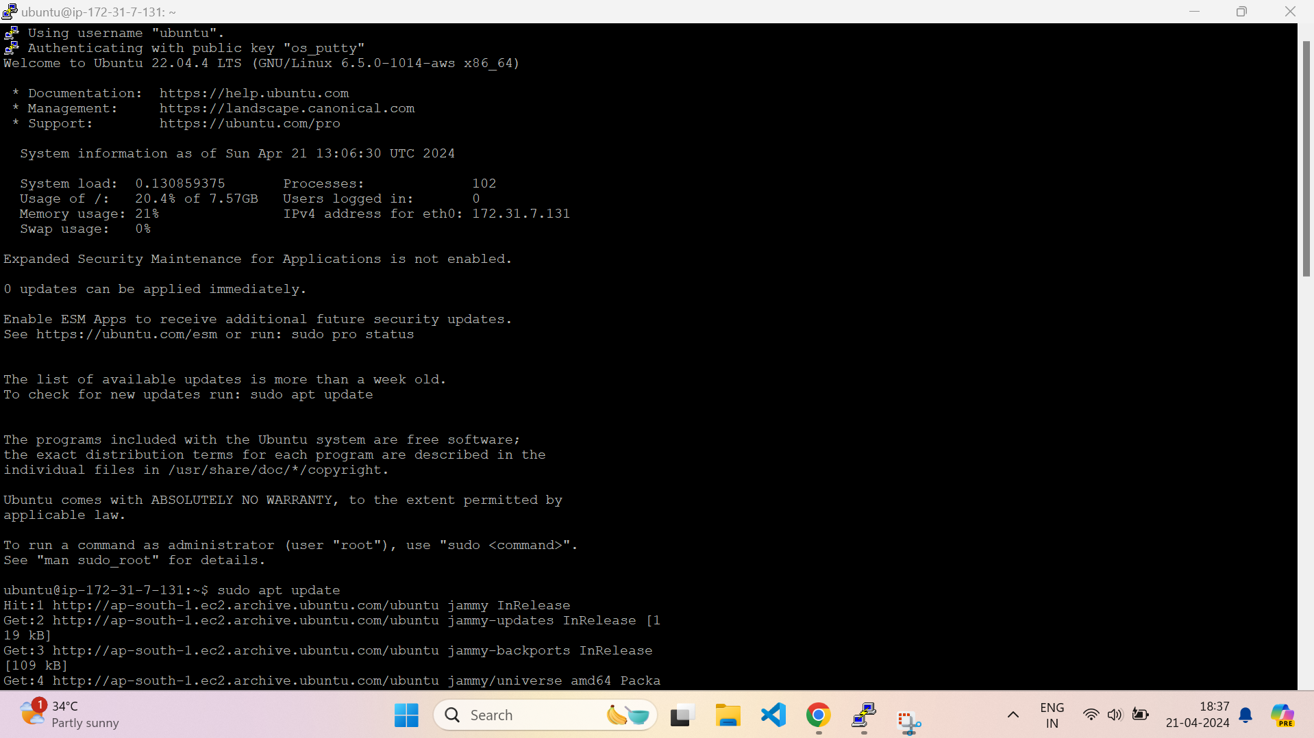

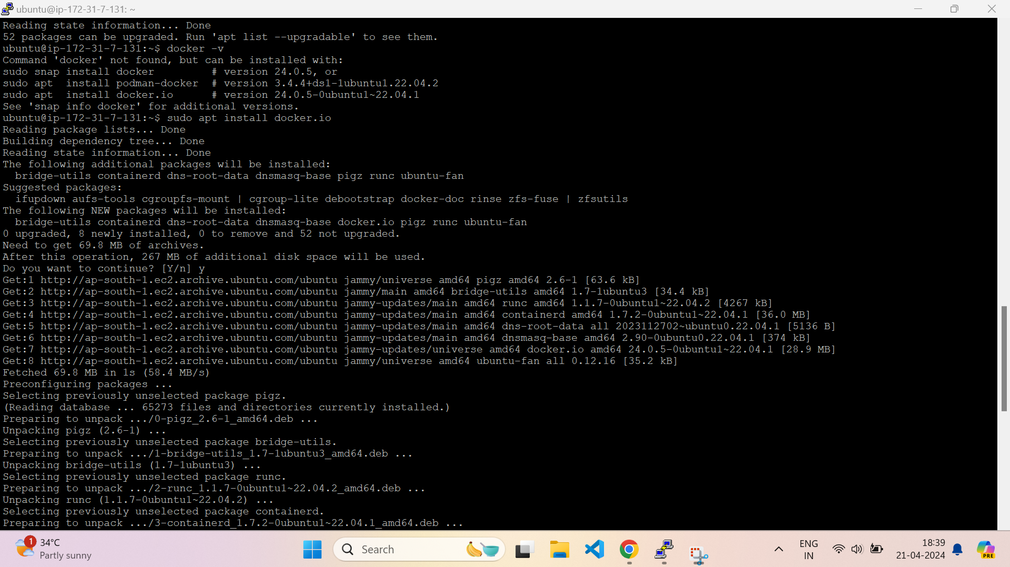

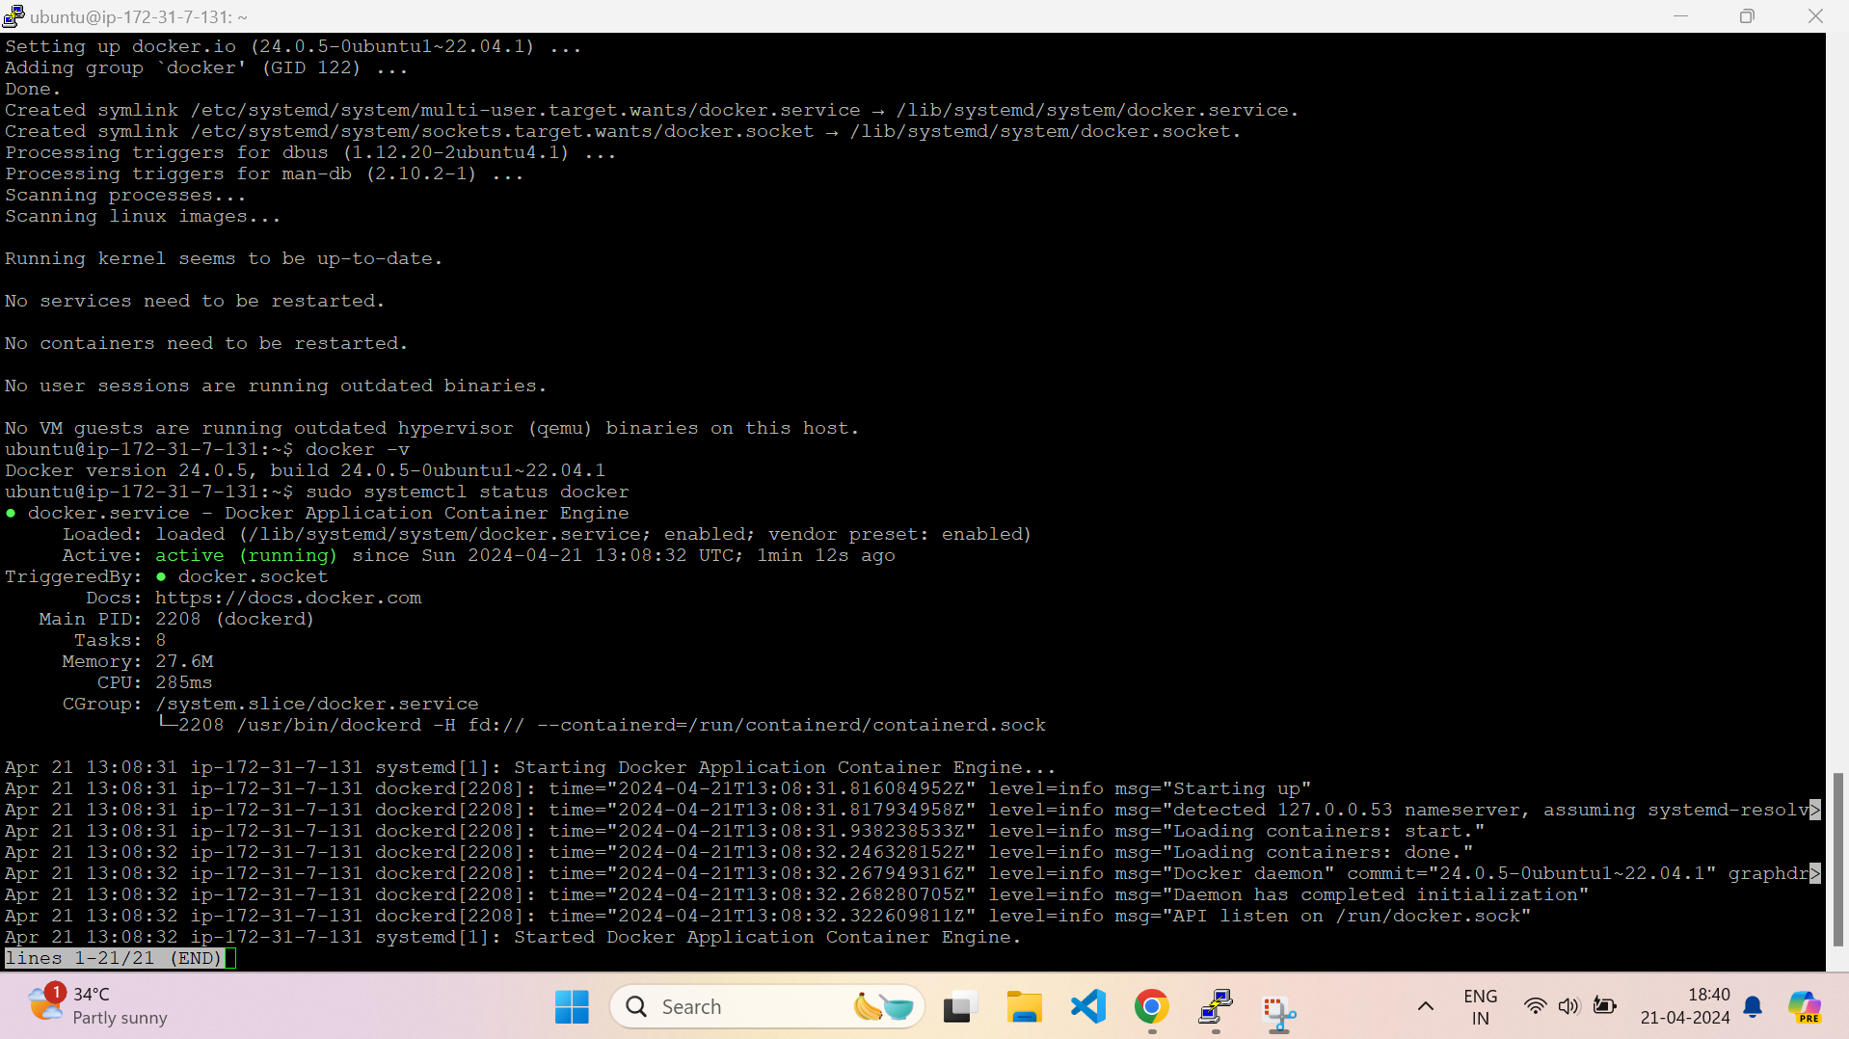

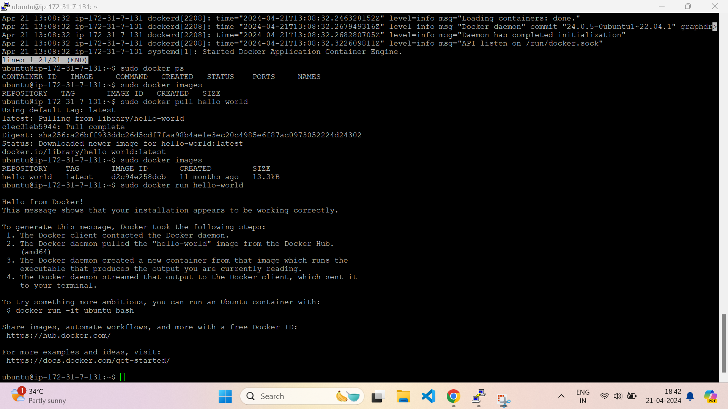

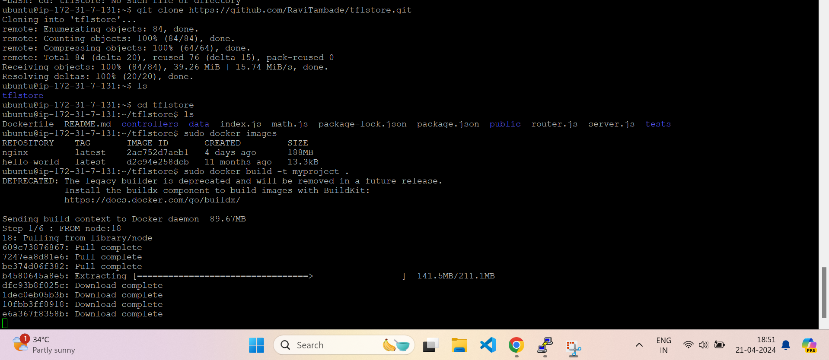

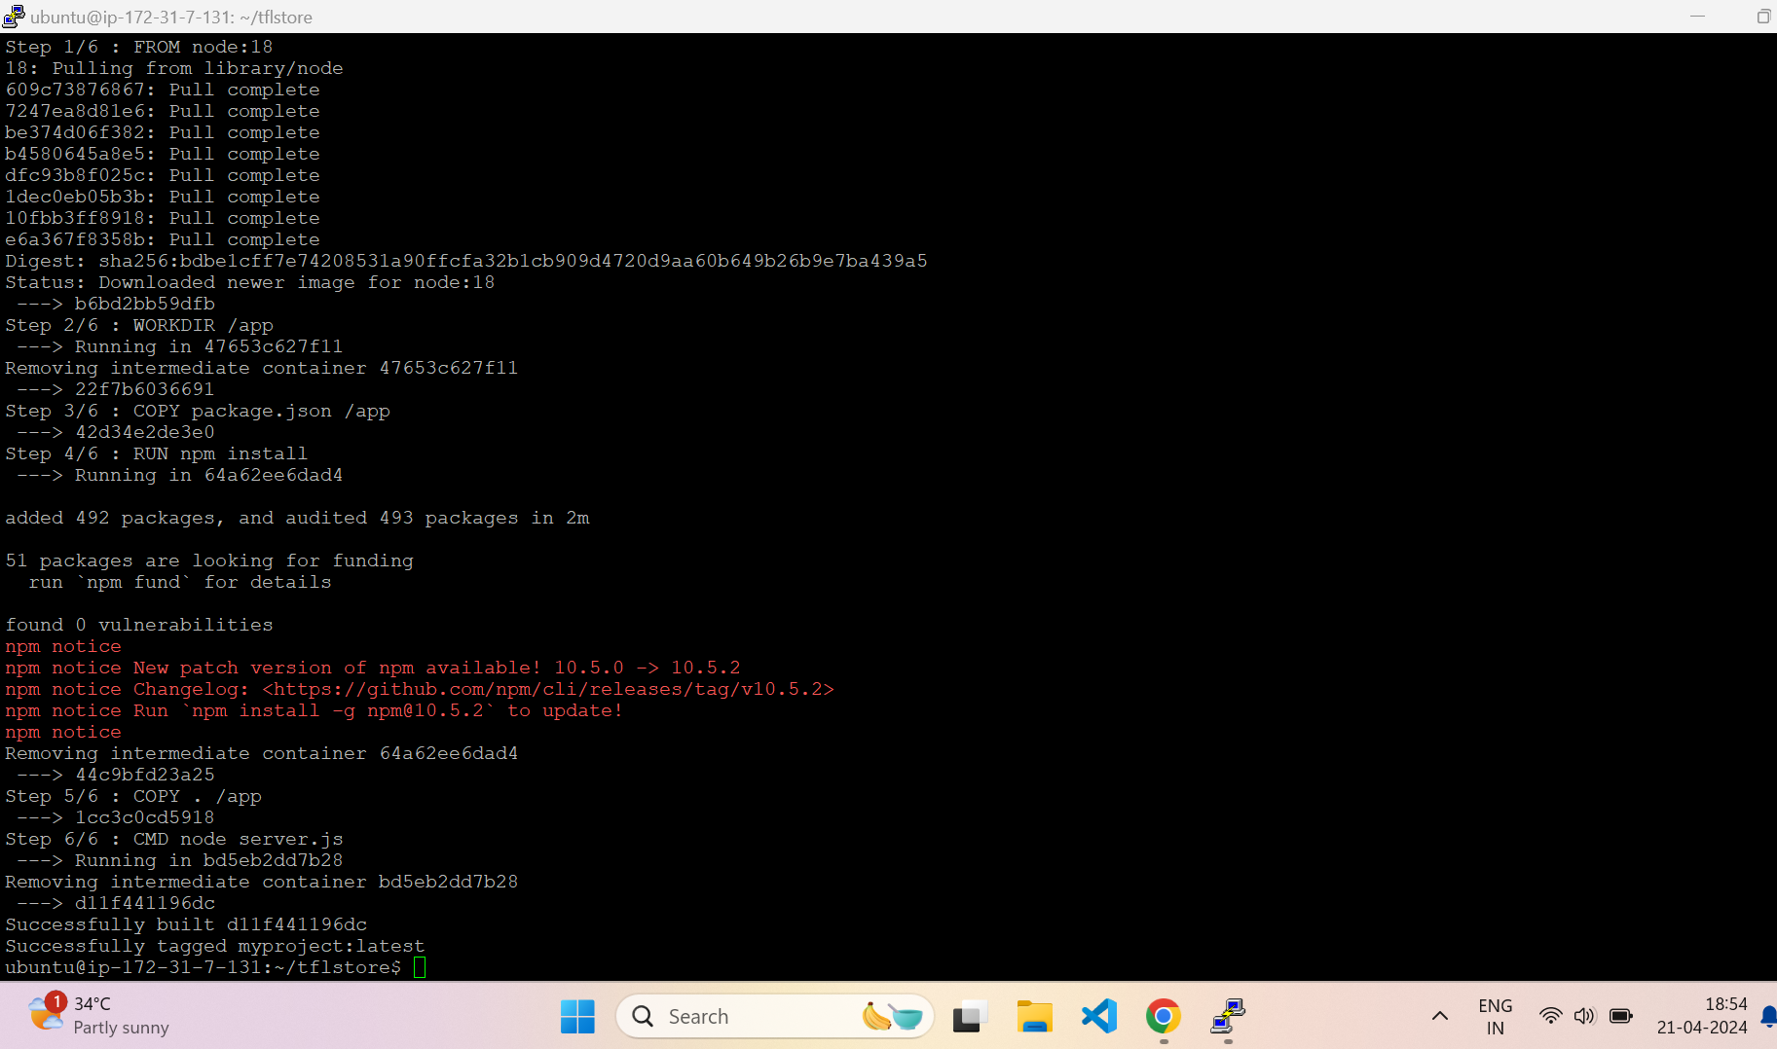

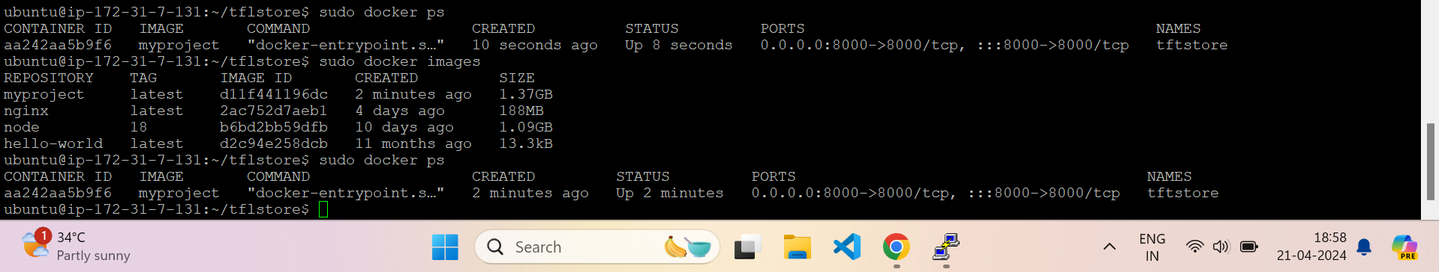



For creating own container

